# COMP3500: Project 5 – Virtual Memory Manager

**🟊: >85%, 🟊🟊: 70-85%, 🟊🟊🟊: 55-70%, 🟊🟊🟊🟊: 40-55%, 🟊🟊🟊🟊🟊: < 40%**

**🟊🟊🟊 Exercise 1 (Plickers):** Given the following system parameters:

* Page table size: 28
* Number of TLB entries: 16
* Page size: 28 bytes
* Physical memory size: 64 KB
* Frame size: 28 bytes
* 16-bit Logical Addresses

How many frames are there?

A. 16 B. 64 C. 128 D. 256

**🟊 Exercise 2 (Plickers):** How large is the logical memory space?

A. 256 Bytes B. 32 KB C. 64 KB D. 128 KB

**Exercise 3:** What are the three key data structures in the paging system?

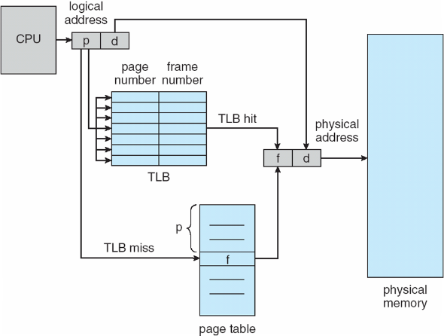

**🟊 Exercise 4 (Plickers):** A user program tries to access data at virtual address X. Which one of the following conditions will never arise?

A. TLB miss, page fault B. TLB miss, no page fault

C. TLB hit, page fault D. TLB hit, no page fault

**🟊🟊 Exercise 5 (Plickers):** Your virtual memory system doesn’t need to deal with the page replacement issue. Why?

A. The page table size equals to the virtual address space.

B. The physical memory size equals to the virtual address space.

C. The physical memory size is larger than the virtual address space.

D. The physical memory size is smaller than the virtual address space.

**🟊🟊🟊🟊 Exercise 6 (Plickers):** Which requires more time to implement? Why?

A. page fault handling B. TLB fault handling.

**🟊🟊🟊🟊 Exercise 7 (Plickers):** Why we want to make sure our system has a functional page table prior to the development of the TLB?

A. The VM system can run without a hard drive

B. The VM system can run without a page table

C. The TLB can run without a page table

D. The VM system can run without a TLB